Certification Project Statement – PHARMA

1. Import the train and test csv.
2. 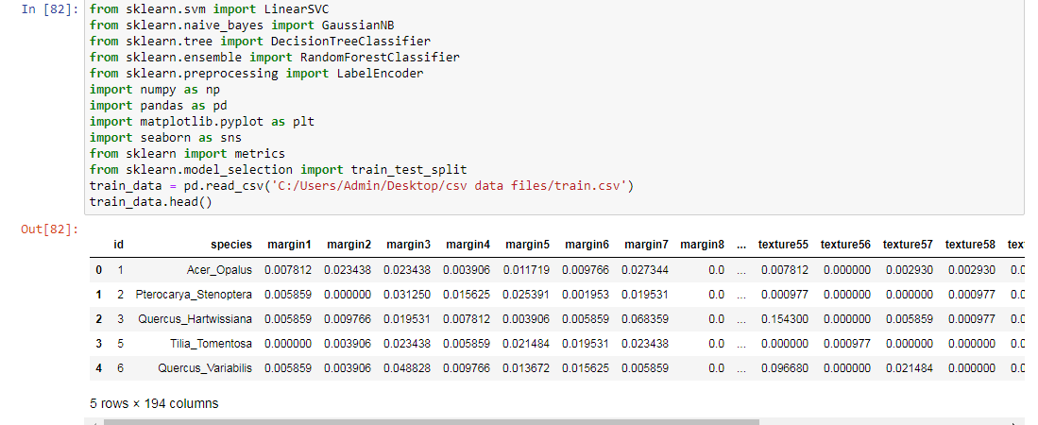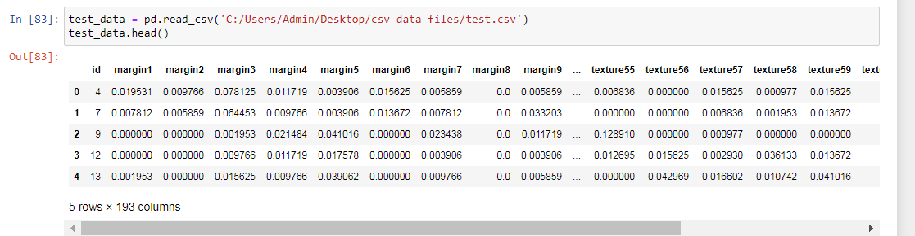
3. 2. Import the required classification libraries along with pandas, numpy, seaborn etc
4. 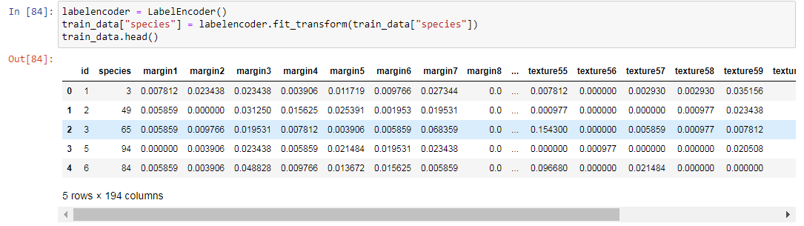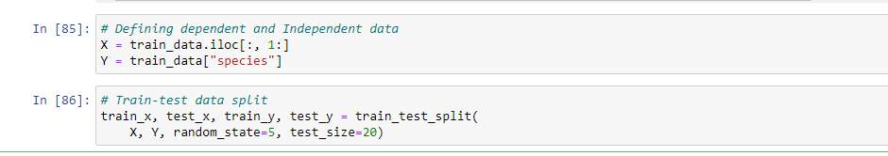

3. Then import the classifiers from them (Randomforest, SVM, NaiveBayes, DecisionTrees)

